**Experiment 2**

PART A

(PART A: TO BE REFFERED BY THE STUDENTS)

**Aim:** **To Subset Report Data using SAS Base**

**Learning Outcomes: Learner should be able to**

1. Apply SAS programming to explore the data provided using basic codes related to it
2. Carry out row filtration
3. Print summary statistics

**Prerequisite: Accessing Data using SAS Programming**

**Activity 1**

**Program:**

proc print data=pg1.storm_summary;

where MaxWindMPH>156;

where MinPressure>800 and MinPressure<920;

run;

1. Run the program. Examine the results and the log.Are the two WHERE statements applied?
2. Change the second **WHERE** statement to **WHERE ALSO** and rerun the code. Examine the results and the log. Are the two WHERE statements applied?
3. State clearly the change in response in the two cases.

**Activity 2**

**Program:**

proc print data=pg1.storm_summary(obs=50);

*where MinPressure is missing; /*same as MinPressure = .*/

*where Type is not missing; /*same as Type ne " "*/

*where MaxWindMPH between 150 and 155;

*where Basin like "_I";

run;

1. Uncomment each WHERE statement one at a time and run the step to **note** the rows that are included in the results. (**Mention the count** for each where statement).
2. Comment all previous WHERE statements. Add a new WHERE statement to print storms that begin with Z. **How many storms are included in the results**?

**Activity 3**

**Program:**

%let BasinCode=NA;

proc means data=pg1.storm_summary;

where Basin="&BasinCode";

var MaxWindMPH MinPressure;

run;

proc freq data=pg1.storm_summary;

where Basin='&BasinCode';

tables Type;

run;

1. Change the value in the %LET statement from NA to SP.
2. Run the program and carefully read the log. Which procedure **did not produce** a report?
3. What is different about the WHERE statement in that step?

**Activity 4**

Create an excel file comprising of own data having Columns PlayerName, Country, Wickets and Average.

1. Print all the data for players having more than 20 Wickets.
2. Print the report showing the count of players from each country.
3. Print the complete statistical summary of players from India and Australia.

**Theory:**

Subsetting in SAS involves selecting a specific portion of data based on certain conditions or criteria. This process is essential for refining your dataset and improving the efficiency of data analysis. SAS provides various tools and techniques for subsetting, including the WHERE statement, IF-THEN/ELSE statements, and data set options like KEEP and DROP.

**Also. refer to the notes shared during the class.**

PART B

(PART B: TO BE COMPLETED BY STUDENTS)

**Paste the screenshot of code and the output for each sub-activity wherever applicable or type the answer.**

Students must submit the **PDF copy** as per following segments within four hours of the practical. The soft copy must be uploaded on the **Teams**. The filename should be **PS_batch_rollno_experimentno Example: PA_A_B001_Exp1**

|  |  |
| --- | --- |
| **Roll No.: A206** | **Name: Harsh Bapu Salunke** |
| **Prog./Yr/Sem: B Tech IT /II/IV** | **Batch: A OR B** |
| **Date of Experiment:** | **Date of Submission:** |

**Activity1:**

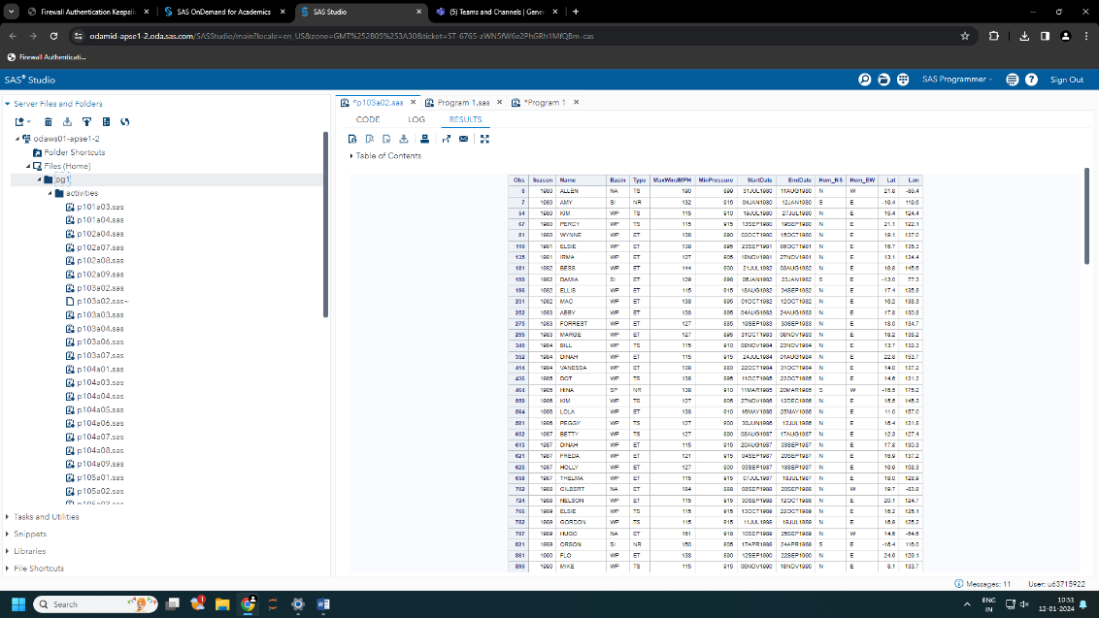

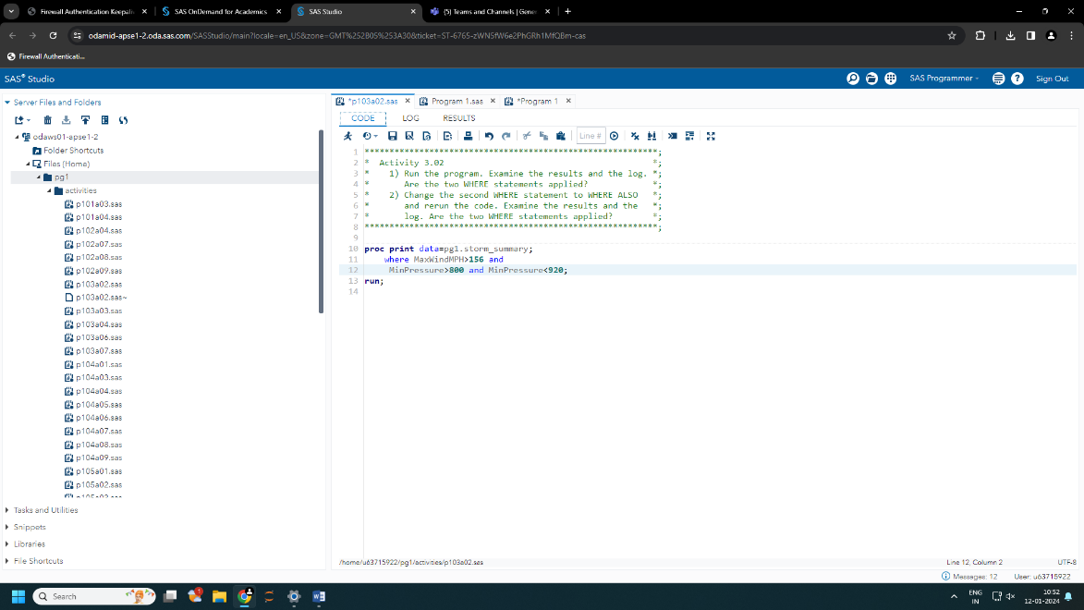

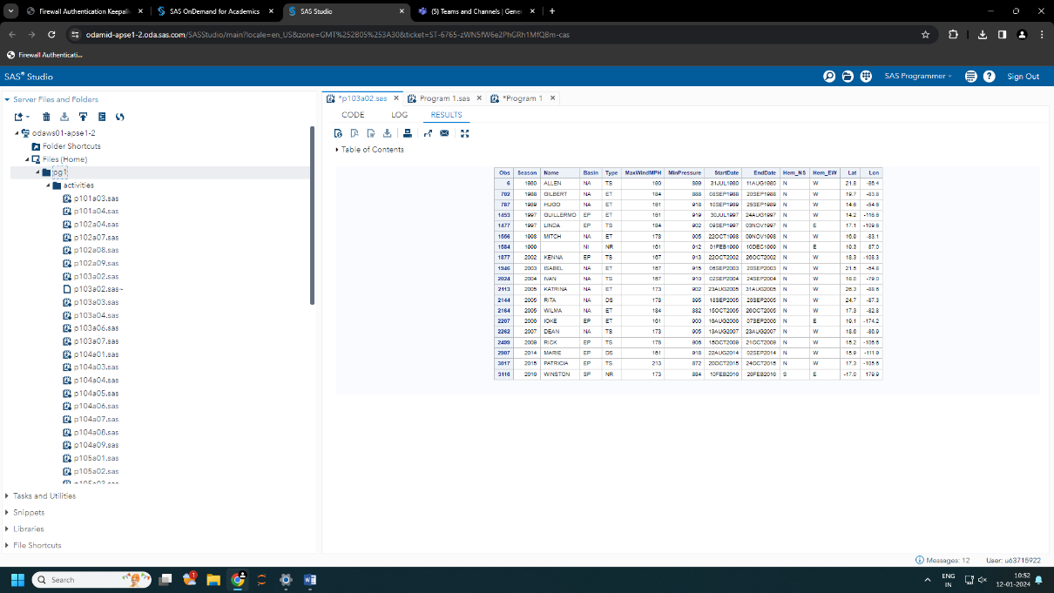

**3] Ans :- there is change in the observations.**

**Activity 2:**

**-There were 50 observation.**

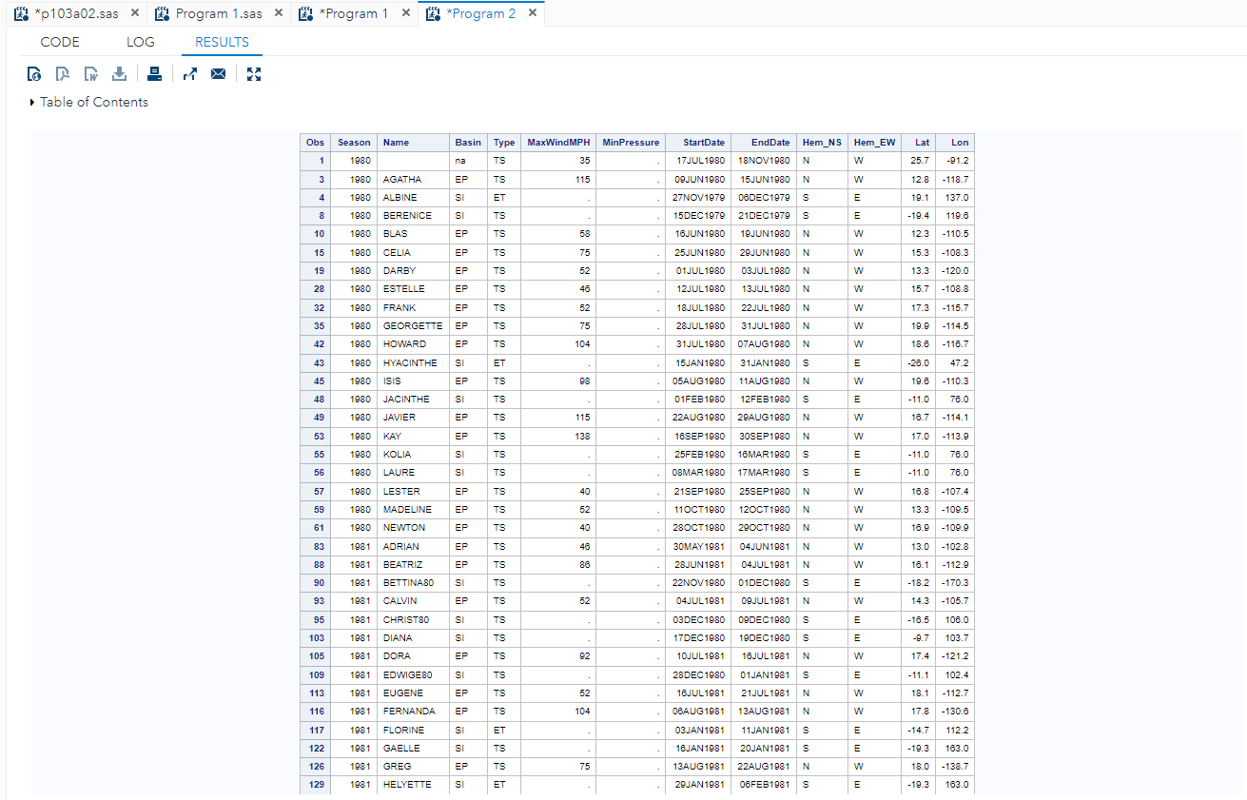

**-There were 50 observation.**

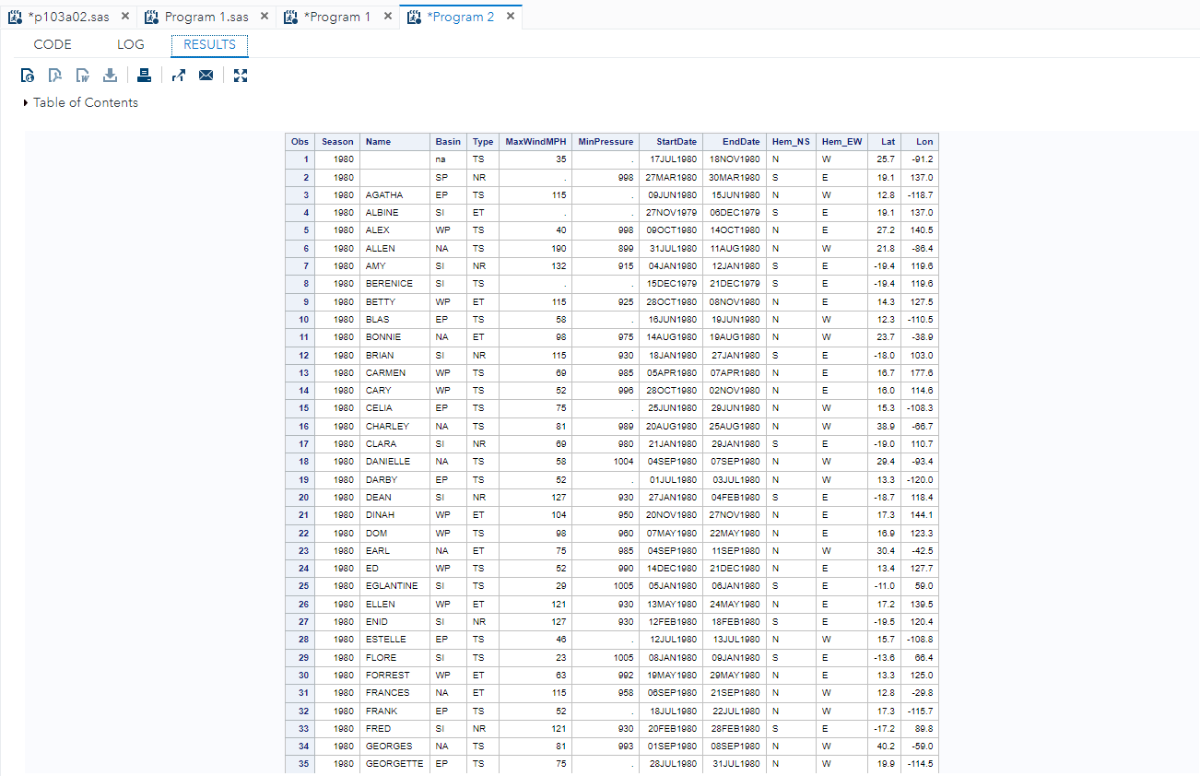

**-There were 36 observation.**

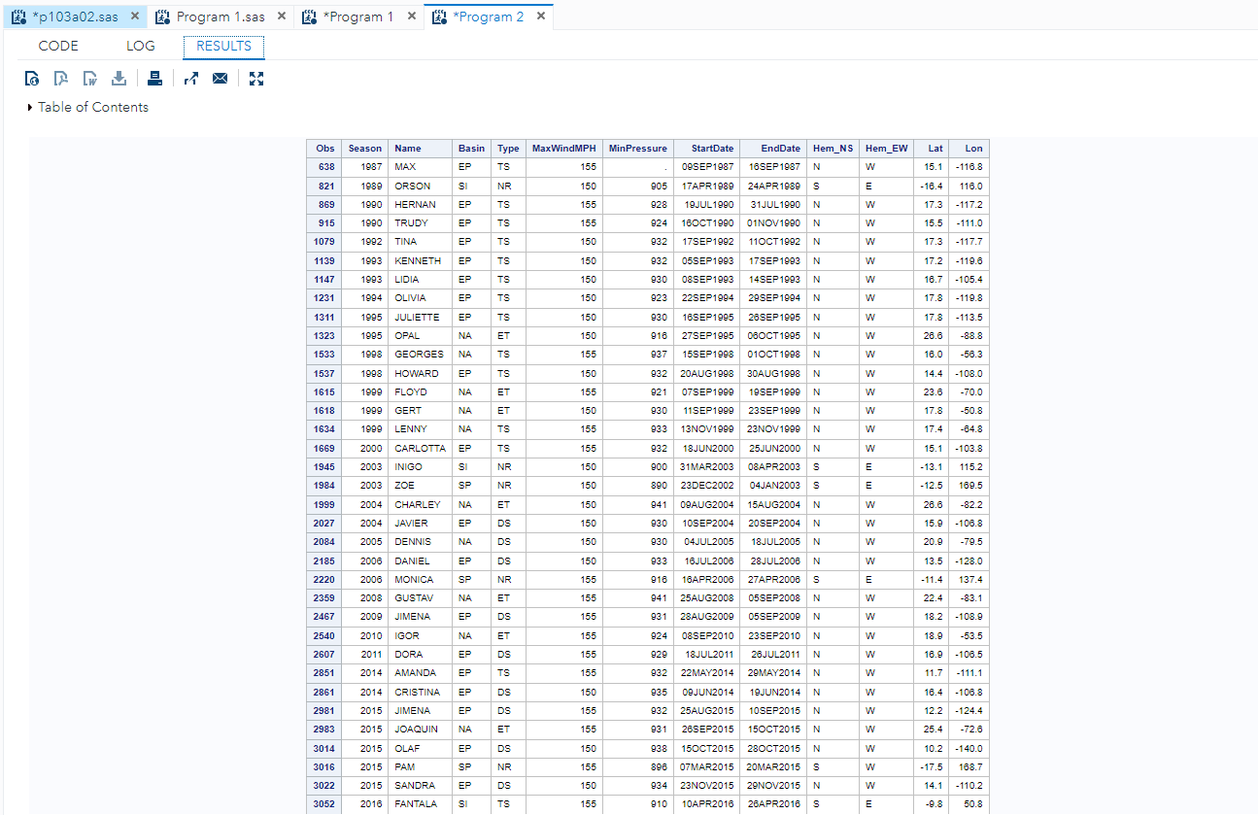

**-There were 50 observation.**

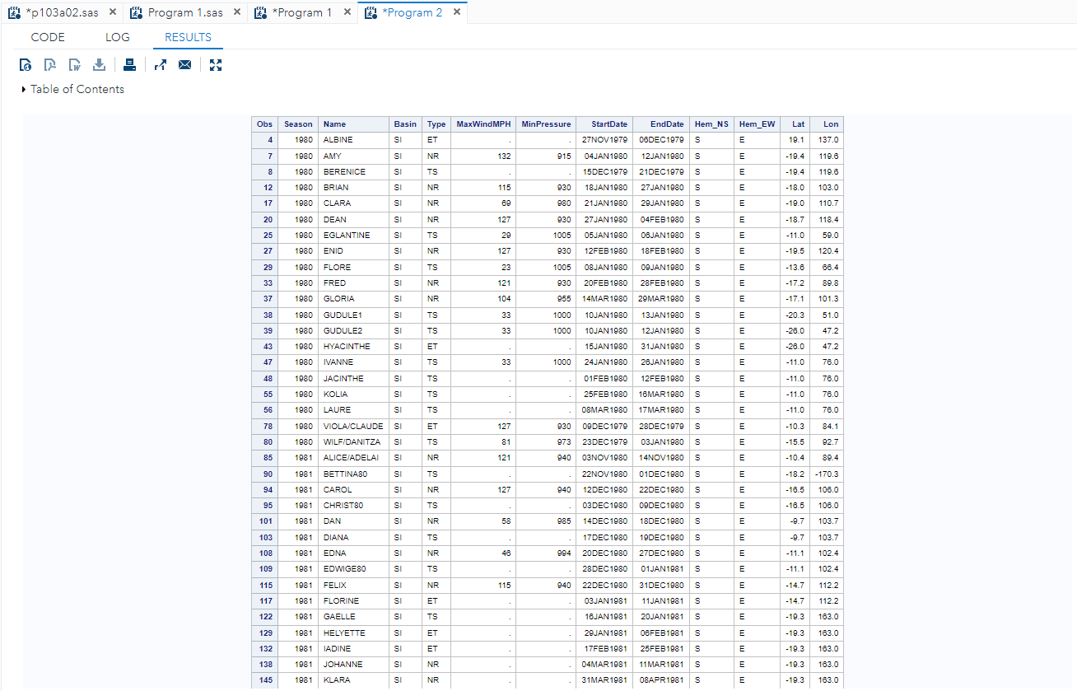

**Code- proc print data=pg1.storm_summary(obs=50);**

* **where name like "Z%";**
* **run;**

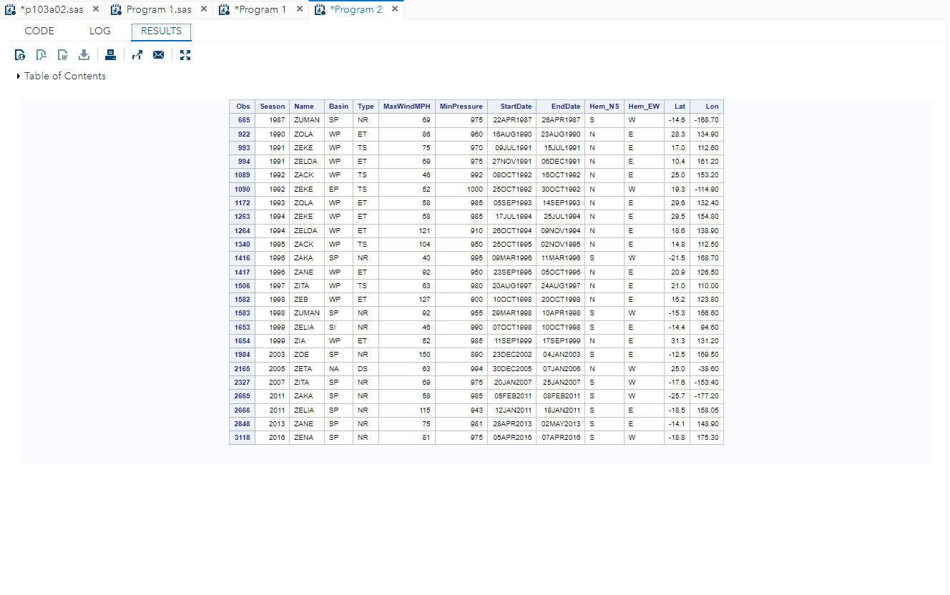

* **There were 24 observations**

**Activity 3:**

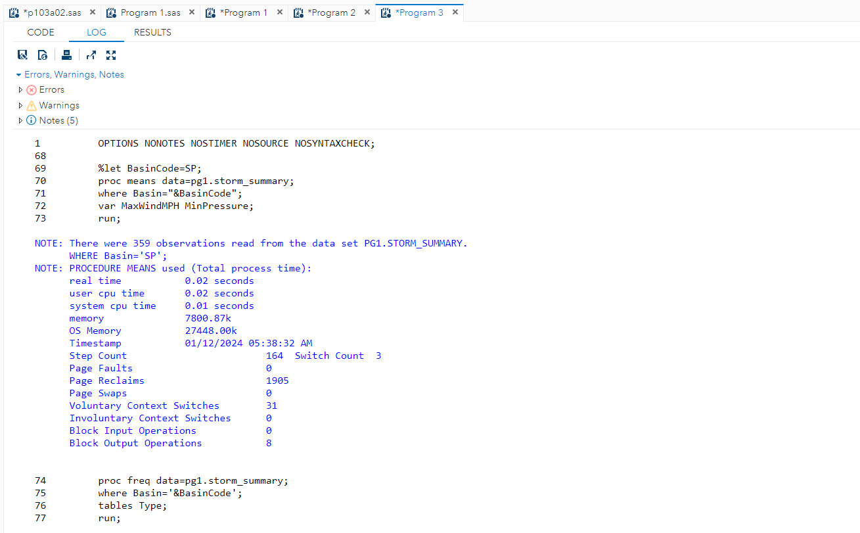

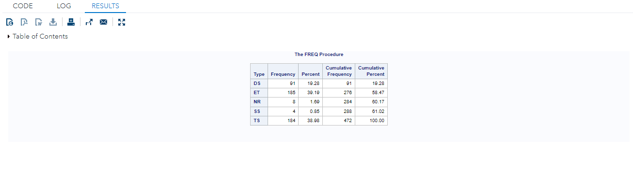

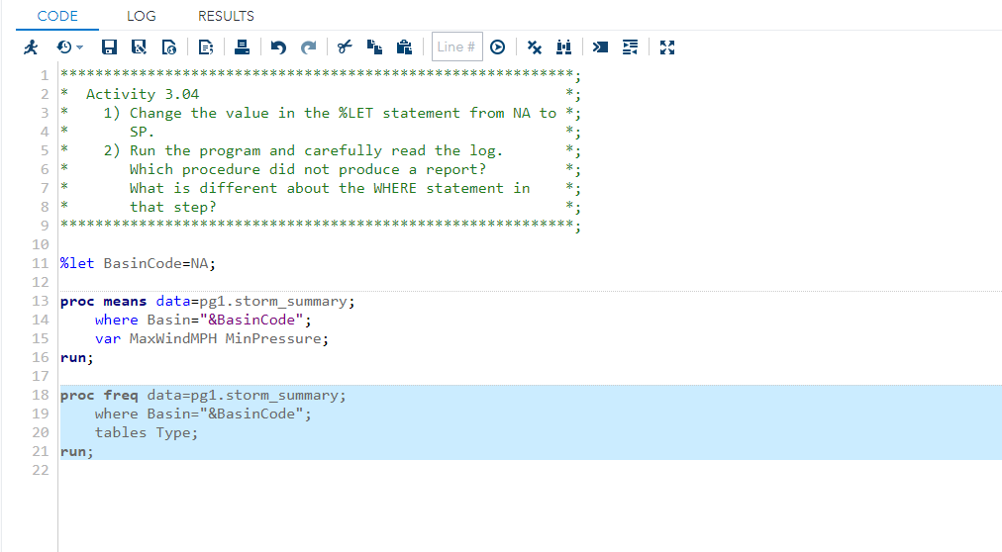

* **Without using micro variable**

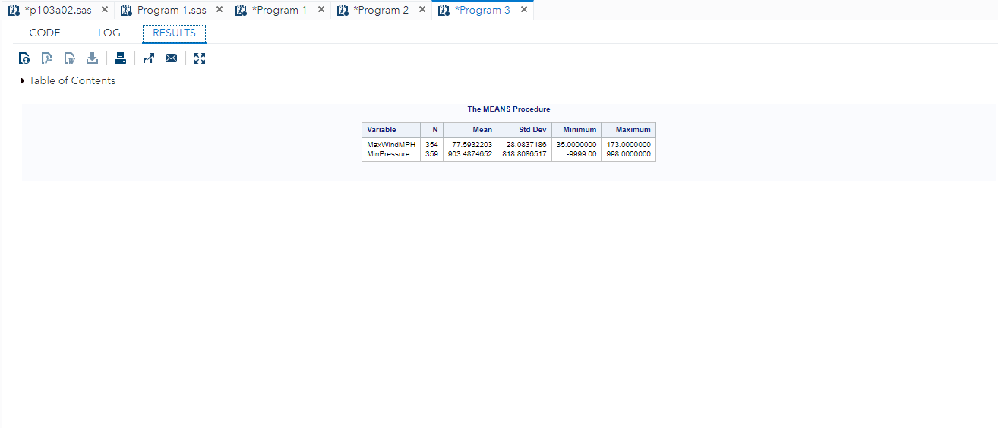

**Activity 4:**

**Activity 5:**

**Activity 6:**

**Conclusion (Learning Outcomes):** Reflect on the activities performed by you and jot down your learnings about the topic.